DATA COMMUNICATION
AND COMPUTER NETWORKS
Complete Study Notes — Beautified Edition
Covers: Network Fundamentals • OSI Model • Topologies • Transmission Media
Line Coding • Switching Methods • TDM • Exam Traps • Master Memory Sheet

Table of Contents

Chapter 1 — Introduction to Computer Networks

1.1 What Is a Computer Network?
A computer network is a collection of interconnected computers, devices, and communication equipment that can exchange information and share resources.
The key word is “interconnected.” A network is not merely a collection of computers sitting in the same room — the devices must have a means of communicating (copper cable, optical fiber, radio, microwave, or another medium).
☆ Simple Picture
Computer A → Network → Computer B
A network allows communication, data exchange, remote services, and resource sharing.

1.2 Goals of Computer Networks
Goal | Explanation
Resource Sharing | Many computers use a common resource — files, printers, storage, internet, databases, applications, servers.
Communication | Email, instant messaging, voice calls, video conferencing, collaboration systems.
Data Sharing | A computer can access information stored on another computer or server.
Remote Access | A user can access resources from another location.
Reliability | Alternate paths and redundant devices keep service running if one component fails.
Cost Reduction | Shared resources reduce the amount of hardware required.
Centralized Management | A server can centrally provide services, authentication, files, and databases.
Scalability | A well-designed network allows new devices/users to be added without a full rebuild.

1.3 Applications of Computer Networks
- Web browsing
- Email
- File sharing
- Online banking
- Online education
- Cloud computing
- Video conferencing
- Remote login
- Online gaming
- Database access
- Printing
- Social networking
- Distributed computing
- Industrial communication
Exam tip: If computers or digital devices communicate, exchange information, or share resources — it is a network application.

Chapter 2 — Network Structure and Architecture

2.1 What Is Network Architecture?
Network architecture describes how computers, clients, servers, and services interact. Two important architectures: Client-Server and Peer-to-Peer.
☆ Don't Confuse
ARCHITECTURE = how systems interact
TOPOLOGY = how devices are physically/logically connected

2.2 Client-Server Architecture
A server provides services; clients request those services. Example: a web browser (client) requests resources from a web server.
Advantages | Disadvantages
Centralized administration & security | Server failure may affect many clients
Easier backup, centralized data | Server can become a bottleneck
Suitable for large organizations | Requires dedicated administration

2.3 Peer-to-Peer Architecture
Computers act as both clients and servers. Example: PC A can request a file from PC B, and PC B can equally request from PC A.
Advantages | Disadvantages
Simple for small networks | Difficult to manage as network grows
No dedicated central server required | Security becomes harder to enforce
Direct resource sharing | Backup and administration less centralized

2.4 Architecture vs Topology
A network can combine Client-Server architecture with a Star topology — no contradiction, since the two terms describe different properties (interaction vs. arrangement).

Chapter 3 — Network Services

3.1–3.2 Service vs Protocol
☆ Golden Rule
SERVICE = WHAT functionality is provided
PROTOCOL = HOW communication is performed (rules)
A protocol is a set of rules governing communication between entities; a service is the functionality made available through those rules.

3.3–3.6 Types of Service
Service Type | Key Idea | Analogy
Connection-Oriented | Establish → Transfer → Release | Telephone call
Connectionless | Packets sent independently, no setup required | Postal system
Reliable | Uses acknowledgements, retransmission, sequencing, error detection/recovery | Registered post
Unreliable | No guaranteed delivery; lower overhead, faster | Ordinary postcard
Note: “Reliable” does not mean physical failure is impossible — it means mechanisms exist to try to achieve reliable delivery.

Chapter 4 — The OSI Reference Model

4.1 Meaning of OSI
OSI = Open Systems Interconnection. It divides communication into seven layers.
☆ Mnemonic (Top → Bottom)
APSTNDP
“Arey Pagle Suno Toh Nah Diaper Pehen”
Application – Presentation – Session – Transport – Network – Data Link – Physical

4.2 Why Layers?
Layering divides networking work into manageable responsibilities. Each layer uses services from the layer below and provides services to the layer above.
- Modularity
- Easier troubleshooting
- Easier design
- Easier standardization
- Easier modification

4.3–4.9 The Seven Layers
Layer | Function | Memory Cue
7. Application | Network services for applications (web, email, file transfer) | Application = Services
6. Presentation | Translation, formatting, encryption/decryption, compression | Presentation = Representation
5. Session | Establish, manage, and terminate communication sessions | Session = Conversation
4. Transport | End-to-end delivery, segmentation, reassembly, flow control, ports | Transport = End-to-End
3. Network | Logical (IP) addressing, routing, forwarding, packets | Network = Routing
2. Data Link | MAC addressing, framing, local link delivery, medium access | Data Link = MAC / Frame
1. Physical | Electrical/optical/radio signals, voltage, connectors, media | Physical = Bits + Signals
Data Link asks “which device on this local link?” while Network asks “which network/path should the packet use?”

Chapter 5 — Encapsulation and Decapsulation

5.1–5.2 Encapsulation & PDU Names
As data moves down the layers for transmission, each layer adds its own control information (a header, and sometimes a trailer).
☆ PDU Chain (memorize this!)
DATA → SEGMENT → PACKET → FRAME → BITS
Transport→Segment | Network→Packet | Data Link→Frame | Physical→Bits

5.3–5.4 Decapsulation & Peer-Layer Communication
At the receiver, the reverse process (decapsulation) strips each header/trailer as data moves up the layers: Bits → Frame → Packet → Segment → Data.
Corresponding layers on two computers are said to communicate “logically” (e.g., Transport A ↔ Transport B), even though there is no direct cable between them — actual transmission always goes down through all layers, across the medium, and back up on the receiving side.

Chapter 6 — Network Topology

6.1 What Is Topology?
Topology describes the arrangement or connection pattern of devices in a network. Important types: Bus, Star, Ring, Mesh.

6.2–6.5 Topology Types
Topology | Structure | Advantages | Disadvantages
Bus | Devices share one main backbone cable | Simple, inexpensive for small networks | Backbone failure affects all; collisions; hard to expand
Star | Each device connects to a central switch | Easy install/manage; single cable failure isolates only one device | Central device failure disconnects everyone
Ring | Devices form a closed loop | Orderly data flow | Single break can disrupt the loop (unless dual-ring)
Mesh | Every device directly connected to every other | High reliability, multiple paths, strong redundancy | Expensive, many cables/ports, poor scalability
☆ Quick Recall
STAR = Central device
BUS = Main backbone
RING = Closed loop
MESH = Many direct connections

6.5 Mesh — Link Count Formula
For a full mesh with n devices:
Number of links = n(n − 1) / 2
- Example: n = 5 → links = 5 × 4 / 2 = 10
- Example: n = 20 → links = 20 × 19 / 2 = 190
This demonstrates why a full mesh becomes expensive very quickly as devices increase.

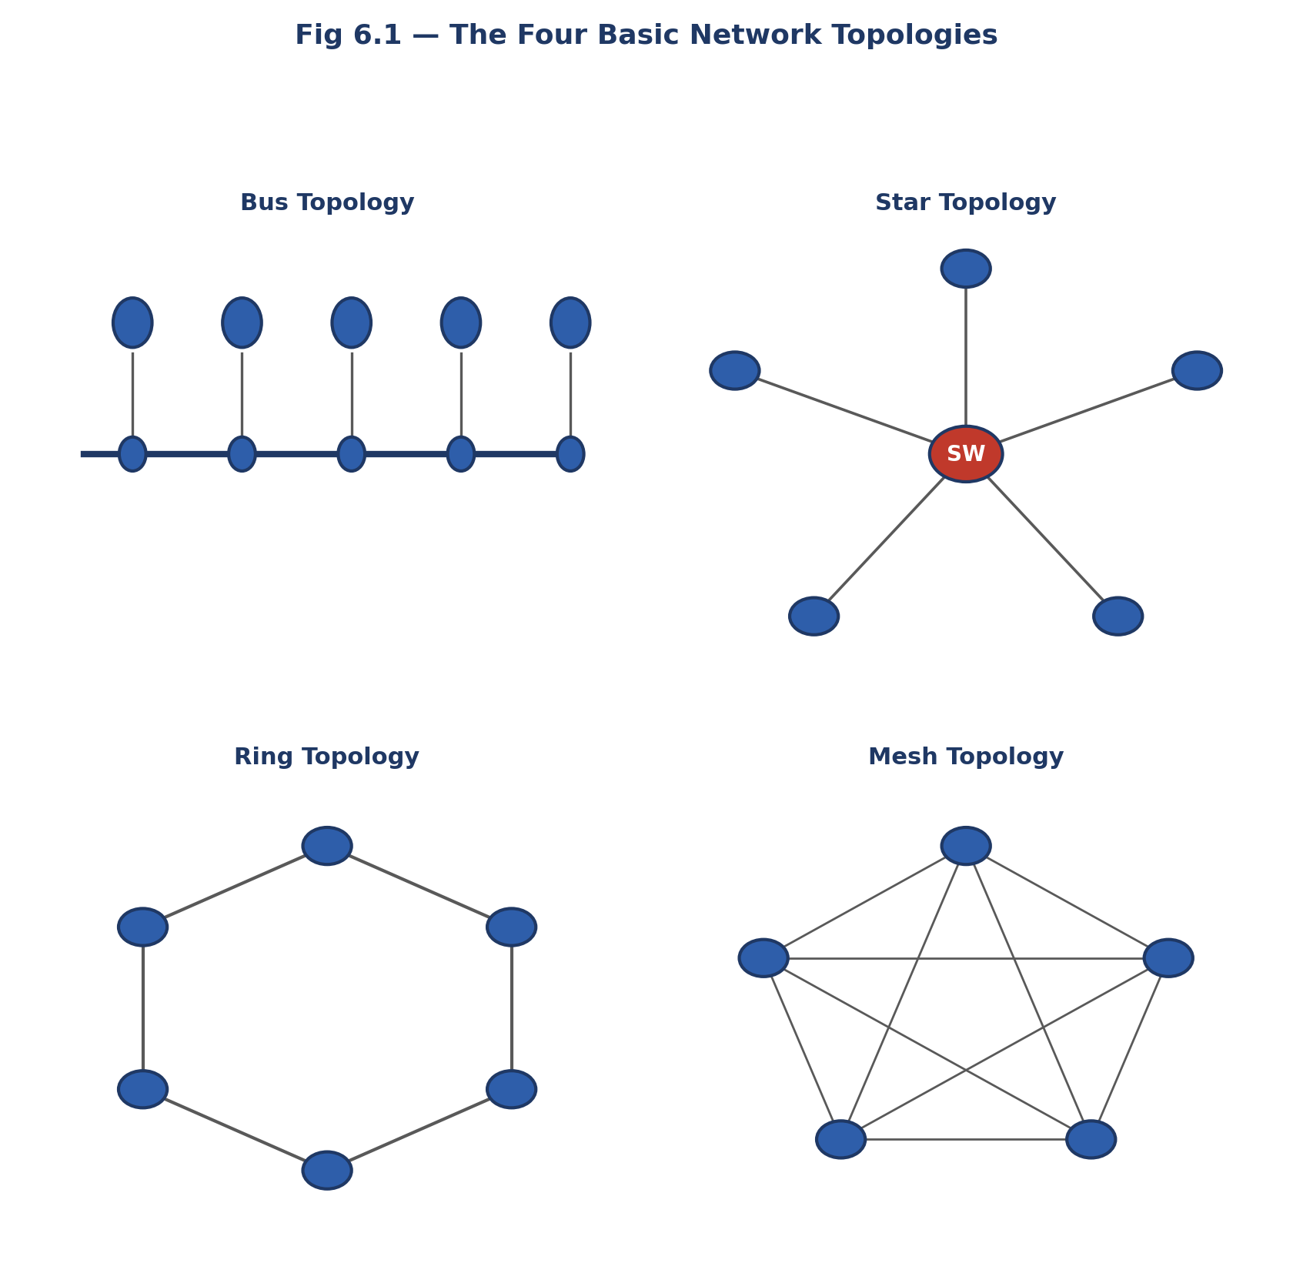

6.6 Topology Design Considerations
- Cost
- Reliability
- Scalability
- Ease of maintenance
- Number of devices
- Cabling
- Failure tolerance
- Management

Chapter 7 — Physical Layer and Transmission Media

7.1–7.2 Transmission Media Overview
Transmission media is the path through which a signal travels from sender to receiver. Two broad categories: Guided (wired) and Unguided (wireless).

7.3–7.6 Guided Media
Medium | Description | Key Feature
Twisted Pair (UTP/STP) | Insulated copper wires twisted together to reduce interference/crosstalk | Copper → electrical signal; UTP cheap & common, STP shielded & costlier
Coaxial Cable | Central conductor + insulation + metallic shield + outer jacket | Shield protects against interference
Optical Fiber | Transmits data as light through glass/plastic fiber | Very high bandwidth, low attenuation, immune to EMI, long distance
- Single-mode fiber: one main light path — used for long-distance, high performance.
- Multimode fiber: multiple light paths — used for shorter distances.

7.7–7.10 Unguided Media
Medium | Typical Use
Radio Waves | Wireless networking, cellular, radio, IoT
Microwaves | High-frequency directional links; needs line-of-sight
Infrared | Short-range; blocked by obstacles; not for wide-area coverage
☆ Guided vs Unguided
GUIDED = physical path (Twisted Pair, Coaxial, Fiber)
UNGUIDED = free space (Radio, Microwave, Infrared)

Chapter 8 — Line Coding Schemes

8.1–8.2 What Is Line Coding?
Line coding determines how digital bits are represented as a digital signal for transmission over a medium. Key properties to compare: synchronization, DC component, bandwidth, number of transitions, error detection, complexity.

8.3–8.9 Coding Schemes
Scheme | Rule | Notes
Unipolar NRZ | 1 → +V, 0 → 0V | Has DC component; sync difficult on long identical runs
Polar NRZ-L | 1 → +V, 0 → −V (level represents bit) | Simple, but long runs hurt sync; DC depends on data
NRZ-I | 1 → transition, 0 → no transition | Transition (not level) represents the bit
RZ | Signal returns to zero mid-bit | Better sync, but needs more bandwidth
Manchester | Transition in the MIDDLE of every bit | Excellent sync/clock recovery; higher bandwidth need
Differential Manchester | Middle transition = clock; transition at START = data | Convention-dependent 0/1 assignment
AMI | 0 → 0V; 1s alternate +V/−V | Reduced DC component; bipolar violations aid error detection
☆ Level vs Transition
NRZ-L: LEVEL represents the bit
NRZ-I: TRANSITION behaviour represents the bit

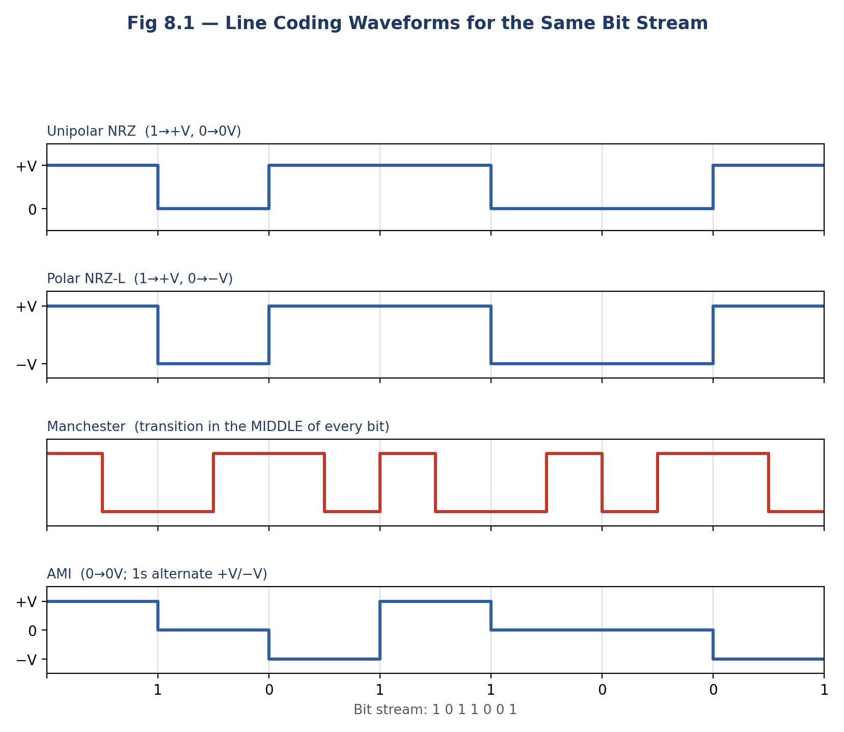

8.10–8.12 DC Component, Synchronization & Bandwidth Trade-off
A DC component appears when the average signal level isn’t centered on zero — undesirable for systems that don’t pass constant DC well.
More transitions generally aid synchronization but demand more bandwidth (higher-frequency content).
Scheme | Transitions | Sync Quality | Bandwidth
Simple NRZ | Fewer | Can be difficult on long runs | Efficient (lower)
Manchester | More (every bit) | Excellent | Higher requirement

Chapter 9 — Switching Methods

9.1–9.4 Circuit Switching
Establishes a dedicated communication path before data transfer. Classic example: the traditional telephone system.
☆ Three Stages
1. Connection Establishment
2. Data Transfer
3. Connection Release
Drawback: resources stay reserved even when the sender has nothing to transmit — wasteful for bursty computer traffic.

9.5–9.8 Packet Switching
A message is divided into smaller packets that share network resources and may travel via different paths/routers to the destination.
Advantages | Disadvantages
Efficient resource sharing | Variable delay
Suited to bursty computer traffic | Queuing and congestion possible
No continuous path reservation needed | Packet loss / out-of-order arrival

9.9 Circuit vs Packet Switching
Aspect | Circuit Switching | Packet Switching
Path | Dedicated | Shared, dynamic
Setup | Required before transfer | Not required
Best for | Continuous traffic | Bursty computer traffic
Analogy | Reserve the road | Share the road

Chapter 10 — Time Division Multiplexing (TDM)

10.1–10.3 Multiplexing & TDM Basics
Multiplexing allows multiple signals/users to share one channel. A MUX combines input streams; a DEMUX separates them at the receiving end. TDM divides the shared channel into time slots, grouped into frames.
☆ Core Idea
MUX = Combine
DEMUX = Separate
TDM = Division by TIME

10.4–10.5 Synchronous vs Statistical TDM
Type | Slot Assignment | Advantage | Disadvantage
Synchronous TDM | Fixed slot per input, always reserved | Simple, predictable | Unused slots waste bandwidth
Statistical TDM | Slots assigned dynamically based on actual traffic | Better utilization for bursty traffic | More complex control needed

10.6 TDM Calculations
Frame duration = N × T (N = number of users, T = slot duration)
- Example: N = 4 users, T = 2 ms → Frame duration = 4 × 2 = 8 ms
Data rate = slots/frame × bits/slot × frames/second
- Example: 8 slots/frame × 1 bit/slot × 1000 frames/sec = 8000 bits/second

10.7 TDM vs FDM
☆ Division Basis
TDM → divides by TIME
FDM → divides by FREQUENCY

Chapter 11 — Important Comparisons

11.1 Data Link vs Network
Data Link | Network
MAC address, Frame, local/link delivery | IP address, Packet, routing, forwarding

11.2 Network vs Transport
Network | Transport
Routing, IP addressing, packet forwarding | End-to-end delivery, segmentation, reassembly, reliability, flow control, ports

11.3 Application vs Presentation vs Session
Layer | Focus
Application | Network services for applications
Presentation | Representation, formatting, encryption, compression
Session | Establishment, management, termination of sessions

11.4–11.5 Media Comparisons
Medium | Material | Signal | Notes
Twisted Pair | Copper | Electrical | UTP / STP
Coaxial | Copper | Electrical | Central conductor + shield
Fiber | Glass/plastic | Light | Very high bandwidth, long distance, EMI-immune

11.6 Circuit vs Packet (Recap)
Circuit Switching | Packet Switching
Dedicated path, reserved resources, connection setup, good for continuous traffic | Packets, shared resources, dynamic forwarding, good for bursty traffic

11.7 Star vs Bus vs Ring vs Mesh (Recap)
Star | Bus | Ring | Mesh
Central device | Main backbone | Closed loop | Multiple direct links

11.8–11.9 NRZ vs Manchester vs Differential Manchester
Scheme | Sync Source | Data Representation
NRZ | Level (weak on long runs) | Direct level per bit
Manchester | Middle transition (every bit) | Direction of middle transition
Differential Manchester | Middle transition (every bit) | Transition (or not) at start of bit

Chapter 12 — Common Examination Traps
Q: Which OSI layer performs routing?
A: Network layer (not Data Link) — routing is a Layer-3 function.
Q: Which OSI layer uses MAC addresses?
A: Data Link layer.
Q: Which layer provides reliable end-to-end delivery?
A: Transport layer.
Q: Which layer handles encryption, compression, translation?
A: Presentation layer.
Q: Which layer manages communication sessions?
A: Session layer.
Q: Difference between service and protocol?
A: Service = WHAT is provided; Protocol = HOW it's carried out.
Q: Which topology uses a central switch?
A: Star topology.
Q: Which topology uses a backbone?
A: Bus topology.
Q: Which topology connects every device to every other?
A: Full mesh — links = n(n−1)/2.
Q: Which medium uses light?
A: Optical fiber.
Q: Which medium is immune to electromagnetic interference?
A: Optical fiber.
Q: Key feature of Manchester encoding?
A: A transition in the middle of every bit period.
Q: Why does Manchester need more bandwidth?
A: It contains more signal transitions.
Q: What does circuit switching establish?
A: A dedicated path.
Q: What does packet switching do?
A: Divides data into packets and shares network resources.
Q: What does TDM divide?
A: The channel by time (into time slots).
Q: Synchronous TDM — source has no data?
A: Its fixed slot remains unused (wasted).

Chapter 13 — One Complete End-to-End Example
Scenario: a browser requests a resource from a remote server. Follow the data down the stack, across the network, and back up at the server.
Step | Layer | What Happens
1 | Application | The Application layer provides network services to the browser.
2 | Presentation | Data formatting, encryption, or compression may be applied.
3 | Session | The communication session is managed.
4 | Transport | Data is segmented for end-to-end delivery: DATA → SEGMENT.
5 | Network | Logical addressing and routing added: SEGMENT → PACKET.
6 | Data Link | Packet placed into a frame with MAC addressing: PACKET → FRAME.
7 | Physical | Frame becomes bits as physical signals: FRAME → 0101…, sent over the medium.
A simplified path: Computer → Router → Router → Server. At the destination, the process reverses (decapsulation): Bits → Frame → Packet → Segment → Data → Application.

Chapter 14 — Master Memory Sheet

OSI Order
☆ APSTNDP
“Arey Pagle Suno Toh Nah Diaper Pehen”
A-Application, P-Presentation, S-Session, T-Transport, N-Network, D-Data Link, P-Physical

OSI Function Memory
Layer | Memory Cue
Application | Network services
Presentation | Format / encryption / compression
Session | Manage communication sessions
Transport | End-to-end delivery
Network | IP / routing / forwarding
Data Link | MAC / frames / local link
Physical | Bits / signals / medium

PDU, Address & Topology Memory
☆ PDU Chain
DATA → SEGMENT → PACKET → FRAME → BITS
Transport→Segment | Network→Packet | Data Link→Frame | Physical→Bits
☆ Addressing
Port → Transport
IP → Network
MAC → Data Link
☆ Topology
Star = Central device
Bus = Backbone
Ring = Loop
Mesh = Many direct connections

Media, Line Coding, Switching & TDM Memory
Category | Memory Cue
Media | Twisted Pair=Copper | Coaxial=Conductor+Shield | Fiber=Light | Radio/Microwave/Infrared=Wireless
Line Coding | NRZ-L=Level | NRZ-I=Transition | RZ=Returns to zero | Manchester=Middle transition | AMI=1s alternate polarity
Switching | Circuit=Dedicated path | Packet=Packets + shared resources
TDM | MUX=Combine | DEMUX=Separate | Synchronous=Fixed slots | Statistical=Dynamic slots

Chapter 15 — Last-Minute Examination Revision
If the exam is about to begin and only five minutes remain, remember the following:
- A computer network allows interconnected devices to communicate and share resources.
- Client-server: Server provides services. Client requests services.
- Peer-to-peer: Peers can act as both clients and servers.
- Star = Central device. Bus = Backbone. Ring = Closed loop. Mesh = Multiple direct connections.
- OSI: APSTNDP — Arey Pagle Suno Toh Nah Diaper Pehen.
- OSI functions: Application→Services, Presentation→Representation, Session→Sessions, Transport→End-to-end, Network→Routing/IP, Data Link→MAC/Frames, Physical→Bits/Signals.
- PDU sequence: DATA → SEGMENT → PACKET → FRAME → BITS.
- Addressing: Port→Transport, IP→Network, MAC→Data Link.
- Transmission media — Guided: Twisted Pair, Coaxial, Fiber. Unguided: Radio, Microwave, Infrared.
- Fiber uses light, offers very high bandwidth, and resists electromagnetic interference.
- Manchester: middle transition, excellent synchronization, higher bandwidth requirement.
- AMI: 0 = zero level; 1s = alternating polarity.
- Circuit switching = dedicated path. Packet switching = packets share network resources.
- TDM divides by time. Synchronous = fixed slots. Statistical = dynamic slots by traffic.
- Service = WHAT is provided. Protocol = HOW communication is performed.
- Most important distinction: MAC→Data Link, IP→Network, Port→Transport.
- Bits must be represented as physical signals for transmission.
- Circuit switching reserves a path; packet switching shares network resources.

Final Professor’s Remark
Do not merely memorize answers to multiple-choice questions — remember the reasoning chain behind each fact:
☆ Reasoning Chains
“Which layer uses MAC addresses?” → MAC → Data Link → Frame
“Which layer performs routing?” → IP → Network → Routing → Packet
“Why is Manchester useful?” → Middle transition → Clock sync → Easier receiver timing
“Why is packet switching efficient?” → Bursty traffic → No permanent reservation → Shared by many → Better utilization
“Why is mesh reliable?” → Multiple links → Multiple paths → One failure doesn’t isolate the network

The purpose of studying Data Communication and Computer Networks is not to memorize isolated definitions — it is to understand how a message travels from one application to another: how it is represented, transported, routed, framed, converted to physical signals, and how the network shares its limited communication resources. Once that complete picture is understood, the individual multiple-choice questions become much easier.

